WEB test – Catch the Queen

Create a responsive game page using the attached slices & mockups according to the following guides:

* The page must be **fully responsive** (min width to consider 375px).
* The page layout should be changed to vertical (mobile layout) at 768px width.
* No need to account for landscape in mobile layout.
* Don't use ES6 (JS classes/arrow functions, LET, Const, etc.).
* Don’t use any CSS framework.
* Don’t use any JS framework/library other than jQuery.
* Don’t use Grunt/Gulp.

mobile layout mockup  
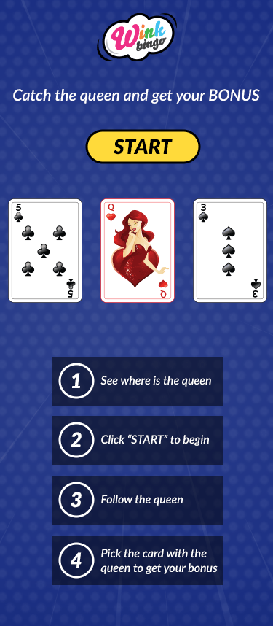

PC layout mockup  
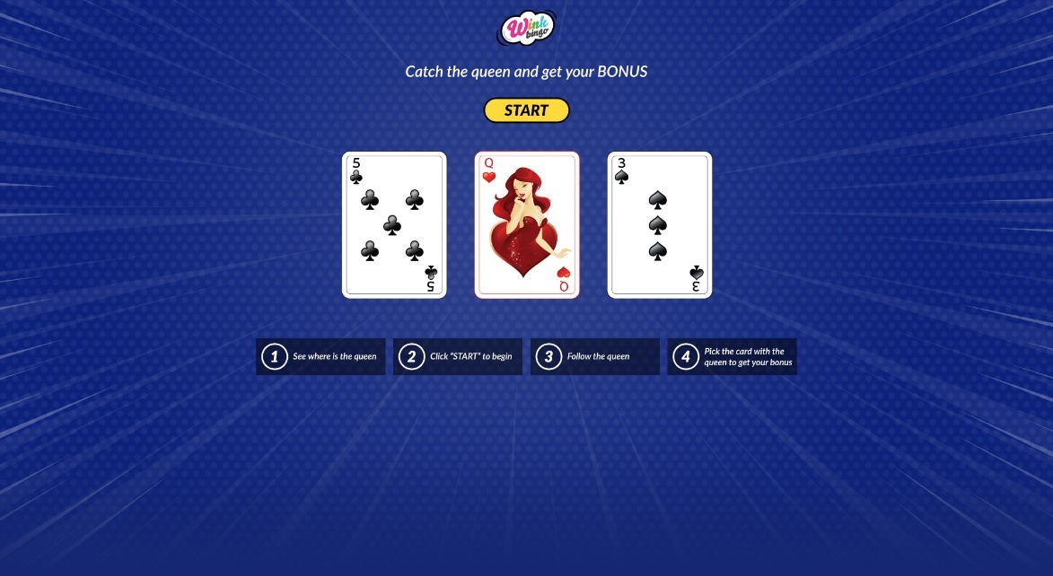

Game flow behavior:

1. Game start with the cards faces visible  
   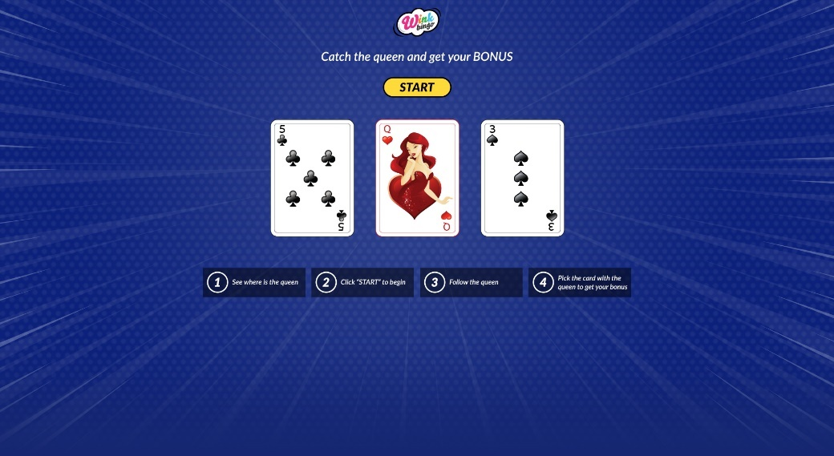
2. Player clicks on "start" to begin the game – the cards flip over   
   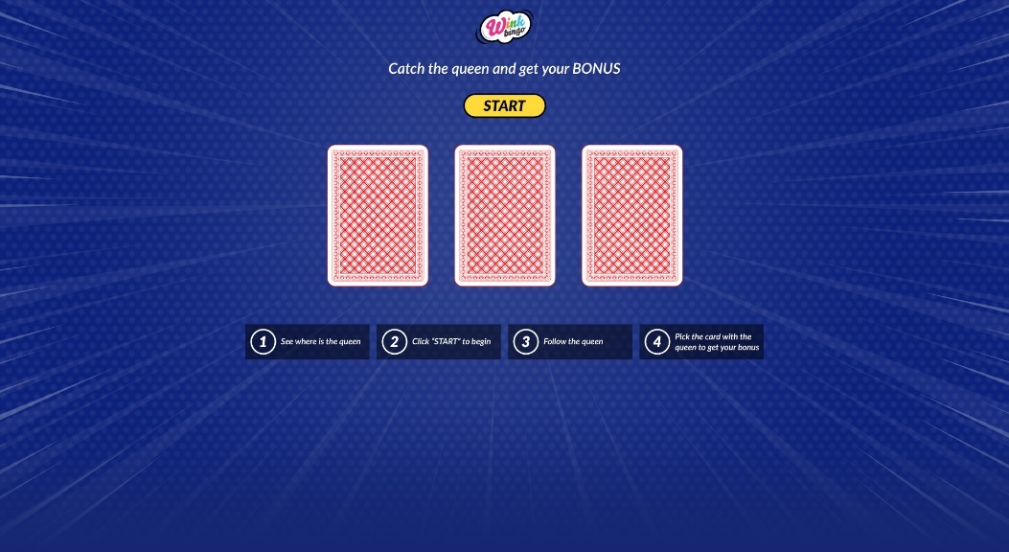
3. Shuffle the cards around a few times (switch position between the cards)  
   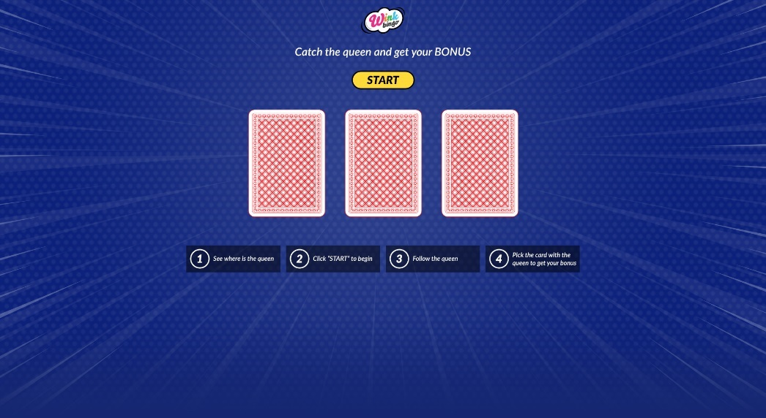
4. The player selects a card, the card turns and a correlating popup appears:  
   1. **correct** (player found the queen) – success popup:  
      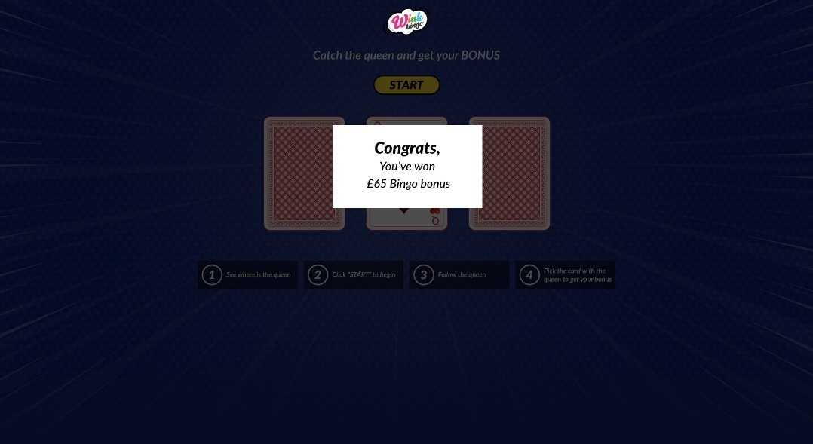
   2. **incorrect** (player didn't find the queen) – lose popup:

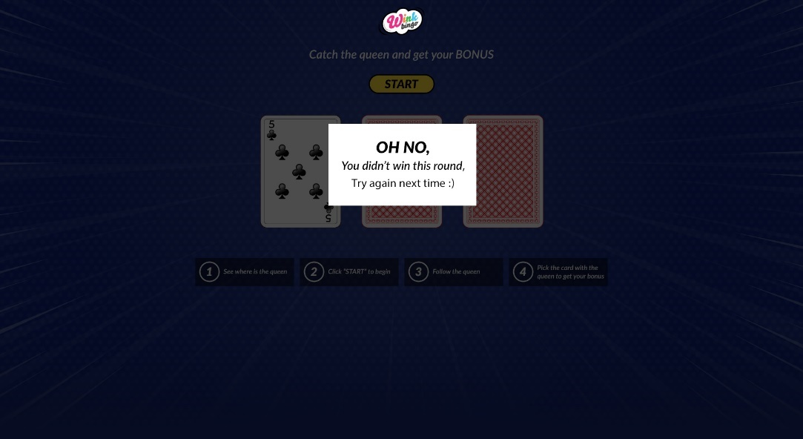

**Elements behavior:**

* once clicked, the "Start" CTA's functionality is removed.
* card selection is only available after the shuffle ends.
* steps will break according the screen width (pc, table, mobile – mockup attached).
* Final popup will be on a darkened BG and disables any elements functionality on the page.
* All assets (except BG) provided at retina resolution (200% of default size).

**Test submission:**

Send a zip containing a folder with all necessary files needed for the game to run according to the above instructions.

**Good luck.**